Structure and Functions assignments

Mandatory
- Refer the code in “student.c”. Implement the following requirements.
  - Change the name member to char * datatype
  - Add 2 functions below to read and store name and percentage scores from user in student record.
//pass name address as parameter and read and update name field Return updated name
char *read_update_name(char *name);

//pass address of percentage as parameter, read and update percentage field of student record. Also return updated percentage
int read_update_percentage(int *percent);
  - Check for memory leaks
  - Specify atleast 5 dataset used for testing
Check for memory leak.
- Code:
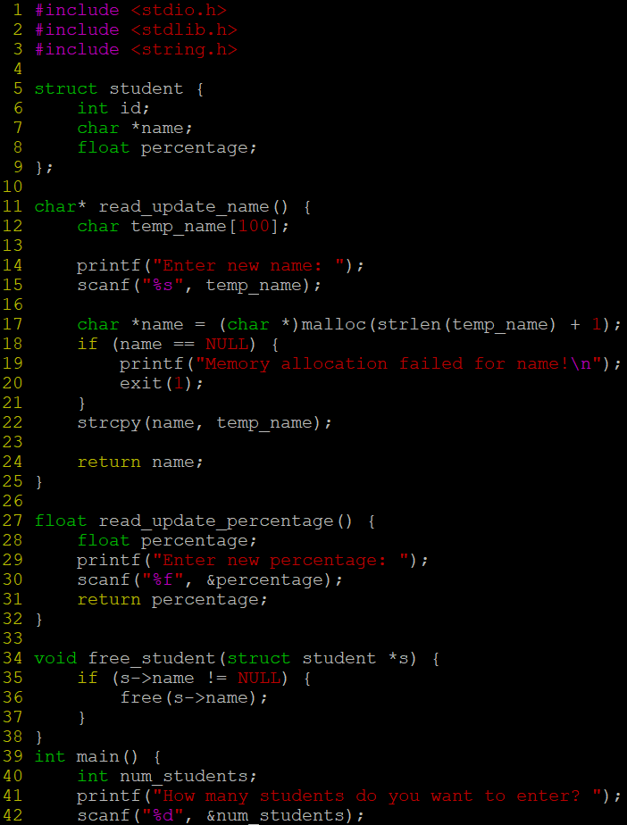
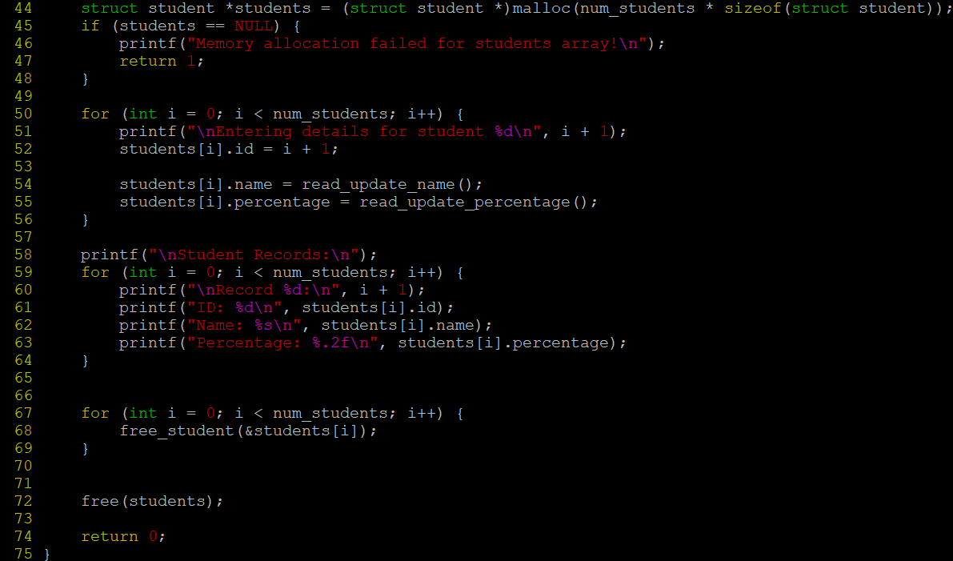
Output:
